Front page

# Foreword (is this right?)

# Version management

|  |  |  |  |  |
| --- | --- | --- | --- | --- |
| **Version** | **Author** | **Date** | **Status** | **Comments** |
| 0.1 | Morcel | 20-02-2018 | Added chapters |  |
|  |  |  |  |  |
|  |  |  |  |  |
|  |  |  |  |  |
|  |  |  |  |  |

Table of Contents

1. Background 5

2. Subject of research 6

3. Goal and Problem Definition 7

3.1. Problem definition 7

3.2. Goal 7

3.3. End-results 7

4. Theoretical framework 8

5. Tools of Research 9

6. Organization 10

7. Planning 11

8. Costs 12

9. Feasibility and risks 13

# 1. Background

In this paragraph the group will describe the background of the project. The background includes everything that has been done prior to the current project and can be of use to the current one.

The current project group consists of nine people of four different universities.

Saxion: Alexander & Morcel

AAU: Jacob, Daniel, Magnus, Robert & Peter

AGU: Ahmet

UTP: Anna

Everyone except for the people for AAU are new to this project. The five guys from AAU have worked on this project half a year prior to the rest and have made a base.

Their assignment was to improve cybersecurity. They took their research to android phones since, according to their research, people store a lot of sensitive data on their smartphones and cybersecurity on smartphones isn’t really a thing yet. Companies as well as regular people have a lot of sensitive data stored on their smartphones, think of bank information and other sensitive data.

To exploit the fact that the market hasn’t really focused on security on android phones they created a honeypot system. This honeypot system in its current state is still very basic and needs improving.

AAU has created a figure of how the honeypot system should work, this is illustrated in the following figure.

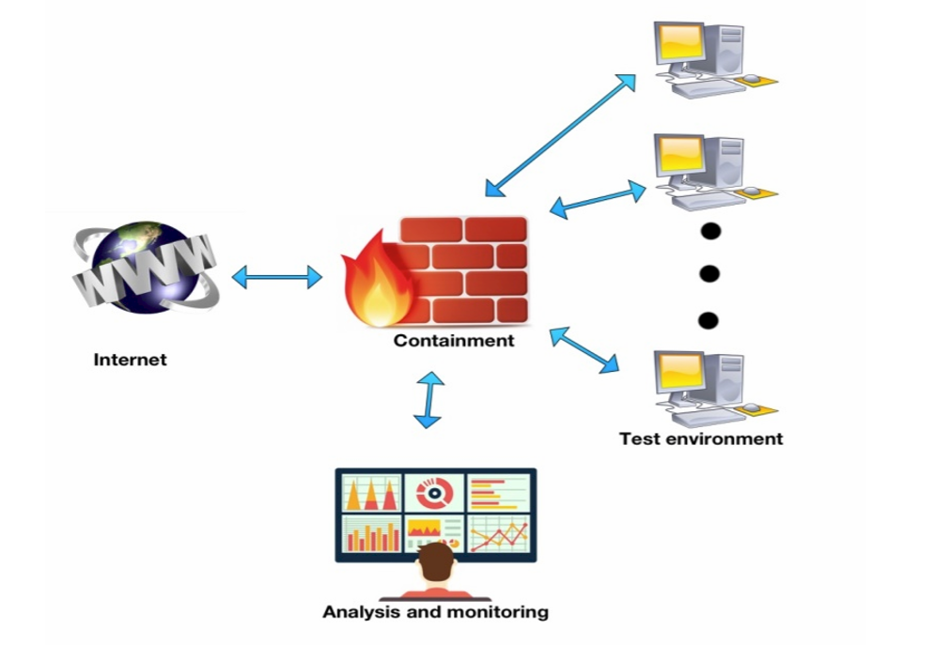

*Figure 1: Honeypot system illustrated*

Now that there is a basis created for the honeypot system we are able to develop it further.

Saxion has brought two business IT students to the project. Their job is to create a system that is appealing for business. How do we sell this product? NOT FINISHED

# 2. Subject of research

# 3. Goal and Problem Definition

In this paragraph the group will describe what the reason for the project is as well as the desired end result when the project is finished. We will do this with the help of research questions. These questions will help us divide the project into smaller chunks. When all the sub-questions have been answered you automatically answered the main issue.

## 3.1. Problem definition

## 3.2. Goal

## 3.3. End-results

# 4. Theoretical framework

# 5. Tools of Research

# 6. Organization

# C:\Users\Morcel\Dropbox\HoneyJar Business\Business\Planning.png7. Planning

# 8. Costs

# 9. Feasibility and risks